bac-1398-1288-800
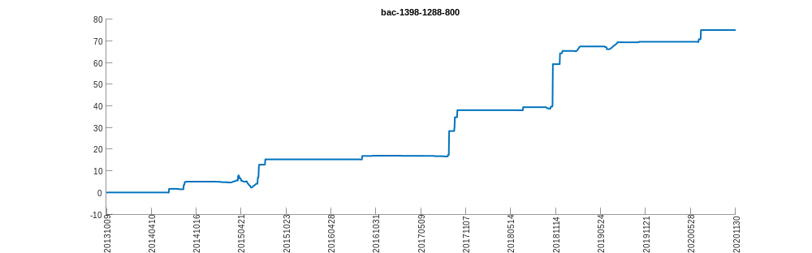
bac-2301-2385-800
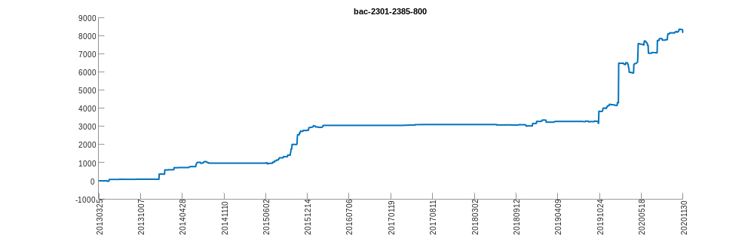
bac-2319-151-800
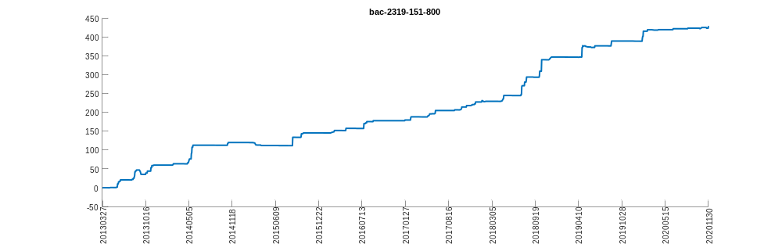
bac-2324-2474-800
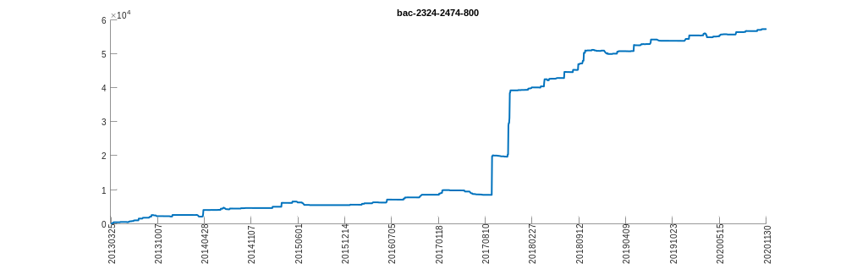
bac-2379-2408-800
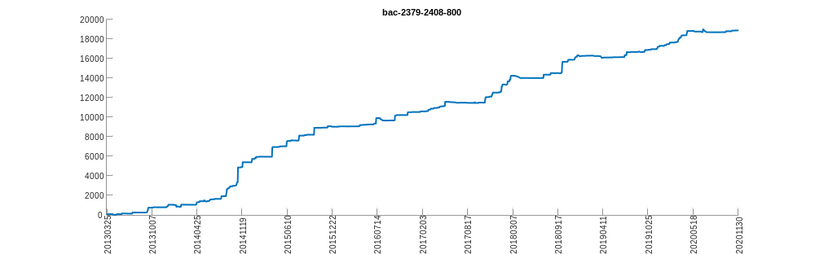
bac-2474-2324-800
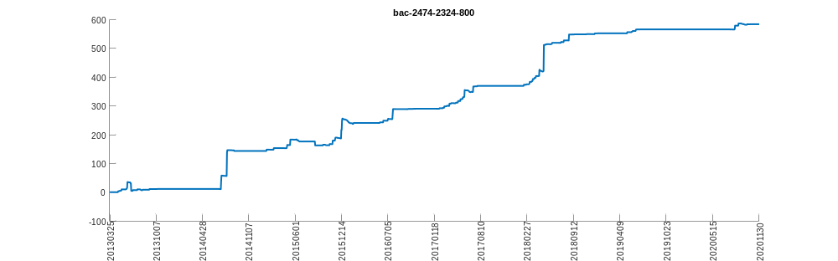
bac-2474-2382-800
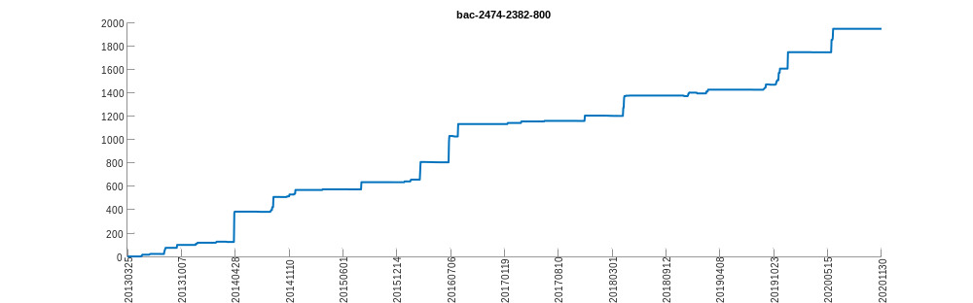
bac-2688-1193-800
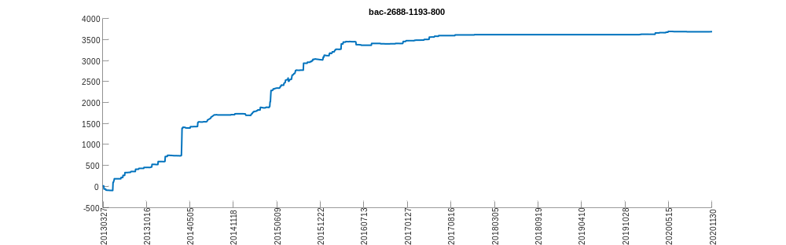
bac-2801-2880-800
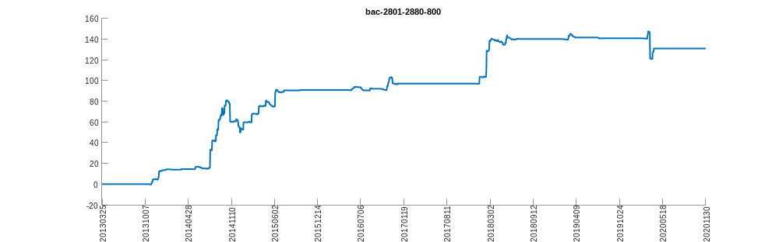
bac-2823-2882-800
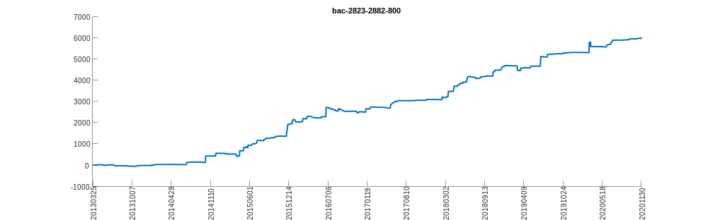
bac-2892-2890-800
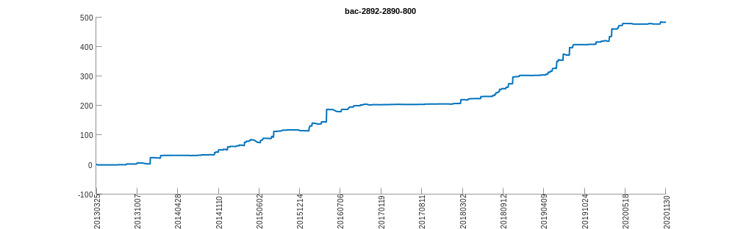
bac-3328-1288-800
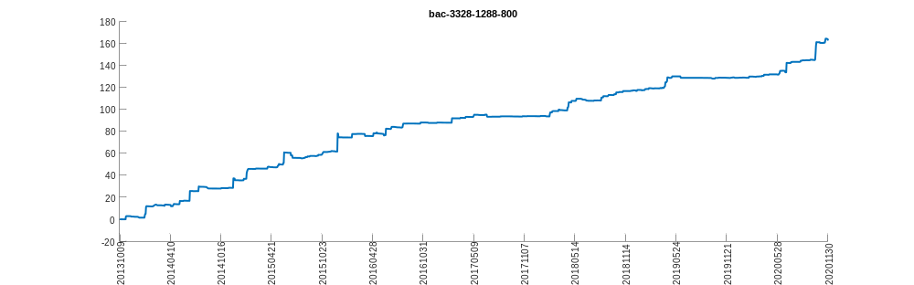
bac-390-1186-800
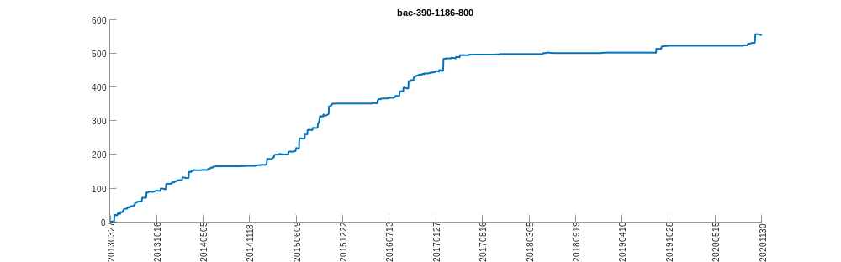
bac-489-2238-800
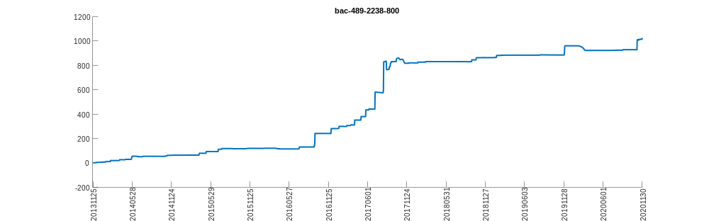
bac-4904-3045-800
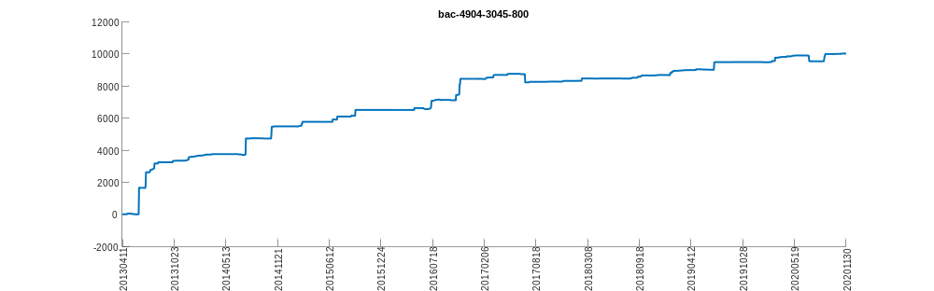
bac-6030-6886-800
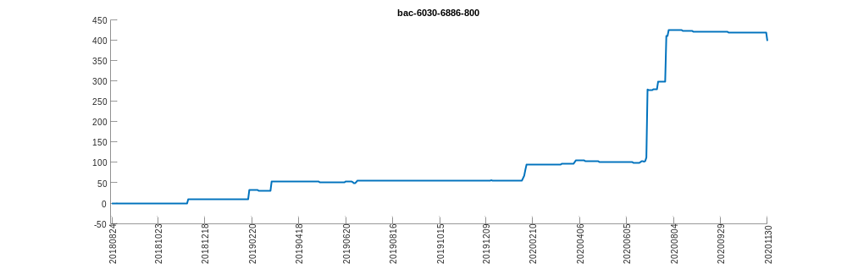
bac-6881-6886-800
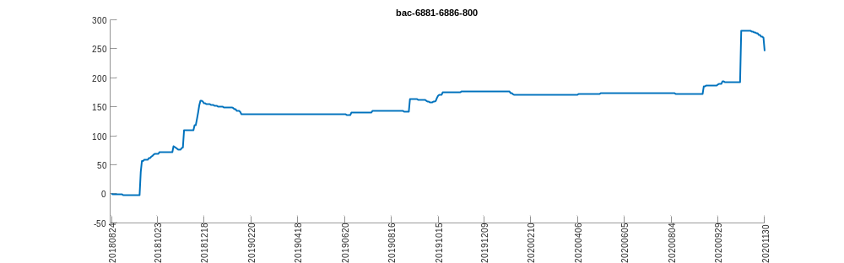
bac-836-1816-800
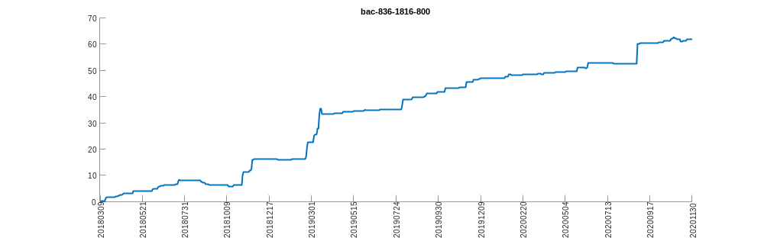
bac-966-2318-800
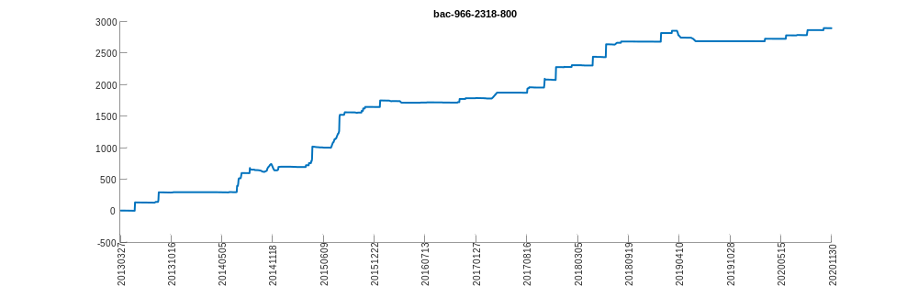
bac-998-1988-800
